1st step: Open Jupyter Notebook and save the code in your Desktop. In case a person doesn’t know the location where the code is saved, you can download the code as an. ipynb file like this:

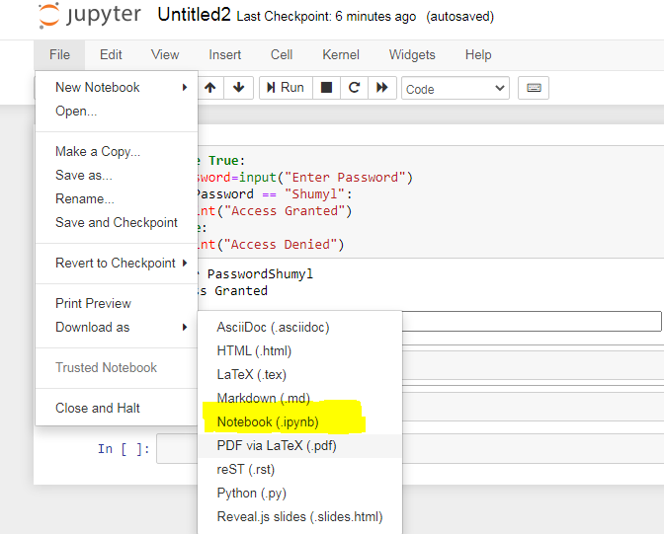

2nd step: Open Google drive and there will be a folder called **“Colab Notebooks”,** open it.

3rd step: After opening Colab notebooks there will be an option called **“New”** on top left of your screen, click on it.

4th step: Choose the option **“File Upload”**, and upload the Jupyter Notebook file you saved

5th step: The file will be upload and displayed on your screen in the Colab Notebook folder, click on the file and on top of your screen, in the middle there will be an option of “**Open with Google Colaboratory”**, click on it and the file will be displayed on Google Colab.